Enterprise Architecture & user expectations

**PREPARED FOR**

Niko Kuijpers

**PREPARED BY**

Maarten Blömer

Nick Krijgsman

Faruk Aydin

Jursley Gonzalez

Vincent Andersen

# Table of Contents

**Table of Contents** **2**

**Case Study** **3**

Case goal: 3

Case questions: 3

Questions: 3

Task distribution 4

**Individual Research** **5**

Vincent 5

1.1 How does this tool aid in determining customer needs? 5

1.2 What are pros and cons to using this tool in creating a product backlog? 6

1.3 Which industry standard diagrams is this tool able to create? 7

Maarten 8

2.1 How does this tool aid in determining customer needs? 8

2.2 What are pros and cons to using this tool in creating a product backlog? 9

2.3 Which industry standard diagrams is this tool able to create? 9

Faruk 11

3.1 How does this tool aid in determining customer needs? 11

3.2 What are pros and cons to using this tool in creating a product backlog? 11

3.3 Which industry standard diagrams is this tool able to create? 12

Nick (LucidChart, Monday.com, StarUML) 14

4.1 How does this tool aid in determining customer needs? 14

4.2 What are pros and cons to using this tool in creating a product backlog? 14

4.3 Which industry standard diagrams is this tool able to create? 14

Jursley 15

5.1 How does this tool aid in determining customer needs? 15

5.2 What are pros and cons to using this tool in creating a product backlog? 15

5.3 Which industry standard diagrams is this tool able to create? 16

**Advice** **17**

# Case Study

## Case goal:

The knowledge gained in this case study has the goal to

• Investigate techniques to investigate customer/stakeholder needs that you can use later on to setup your initial product backlog and technical architecture.

• Investigate standards in modelling software designs and architecture and what their limitations and advantages are.

• Define an outline for architecture document template that offers multiple viewpoints on your architecture.

Direct purpose for your group project:

· Determining customer needs

· Creating a product backlog

· Deciding on which information should be covered in your architectural documentation, which well known diagrams it will hold and which tooling to use to create all of these. Note that your architecture can be refined during this semester in each sprint with relevant new knowledge and insights you gain as a team.

## Case questions:

### Questions:

* How does this tool aid in determining customer needs?
* What are pros and cons to using this tool in creating a product backlog?
* Which industry standard diagrams is this tool able to create?

## Task distribution

|  |  |  |  |  |  |
| --- | --- | --- | --- | --- | --- |
| **Naam** | **Faruk** | **Nick** | **Maarten** | **Vincent** | **Jursley** |
| **UML Tool** | PlantUML | LucidChart | Archi | Structurizr | MooD |
| **Project Management Tool** | ClickUp | Monday.com | VersionOne | Asana | Microsoft Project |
| **Architecture Tool** | C4-PlantUML | StarUML | Archi | Visual Paradigm | Microsoft Visio |

# Brainstorm

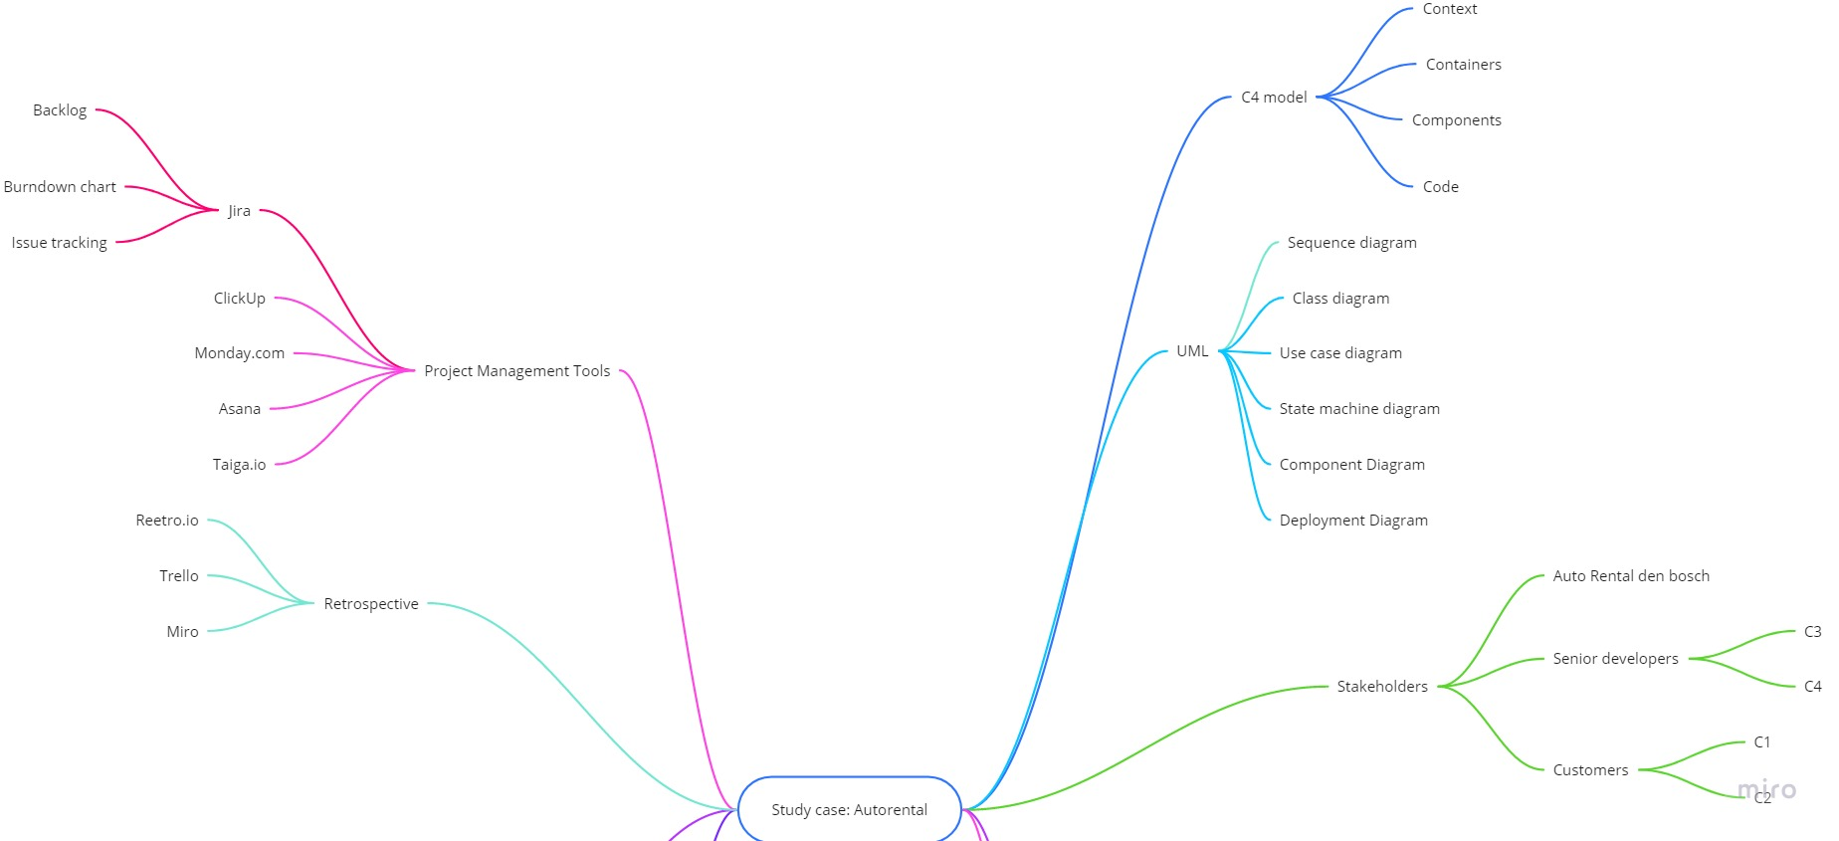

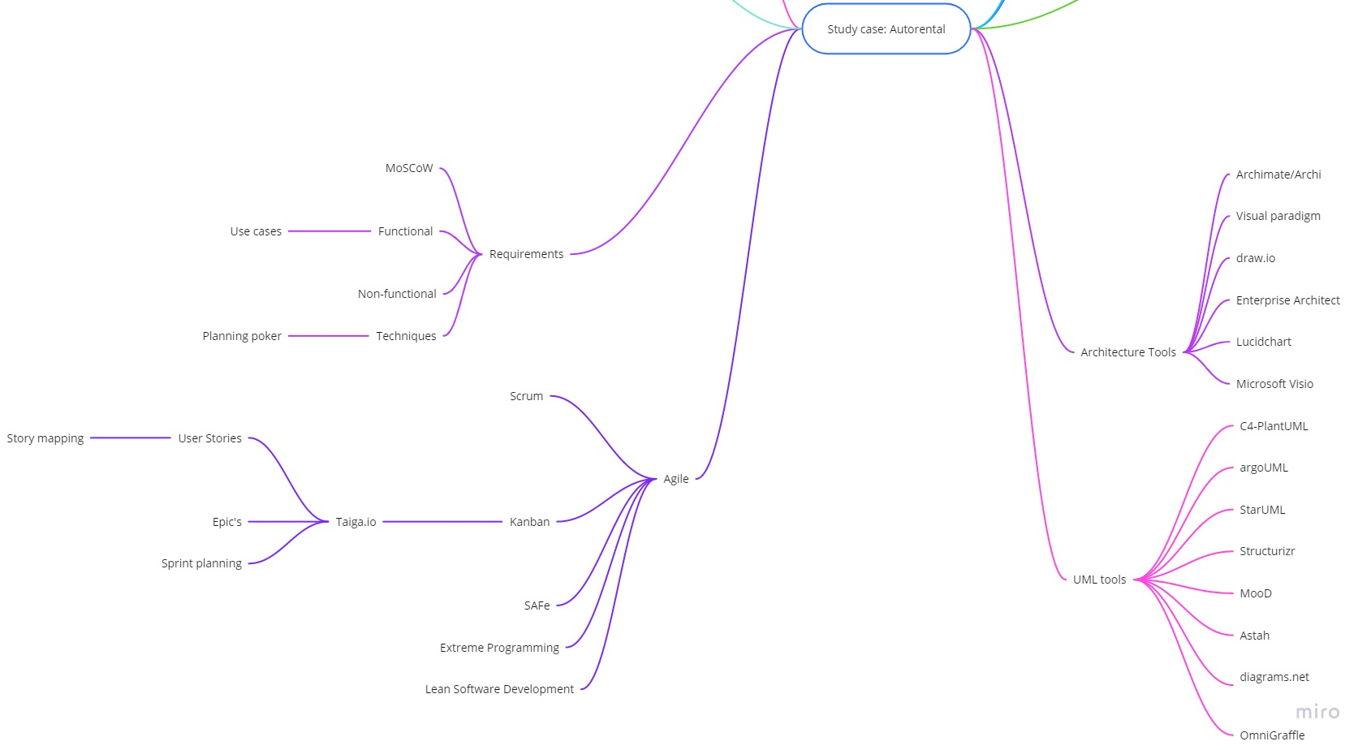

# Individual Research

## Vincent

### 1.1 How does this tool aid in determining customer needs?

**Structurizr**

Structurizr offers software architecture based upon the traditional [C4 Model](https://c4model.com/). The diagrams created by this tool however are highly interactive by allowing the different systems, containers and components to be clickable and show the next step in the hierarchy.  
In order to make it more clear for non technical customers, the diagrams allow simple animations for more clarity during presentations and discussions.

If even more clarity is needed then Structurizr offers supplementary documentation using Markdown or AsciiDoc which are fully navigable and full-text searchable to create context appropriate commentary to diagrams.  
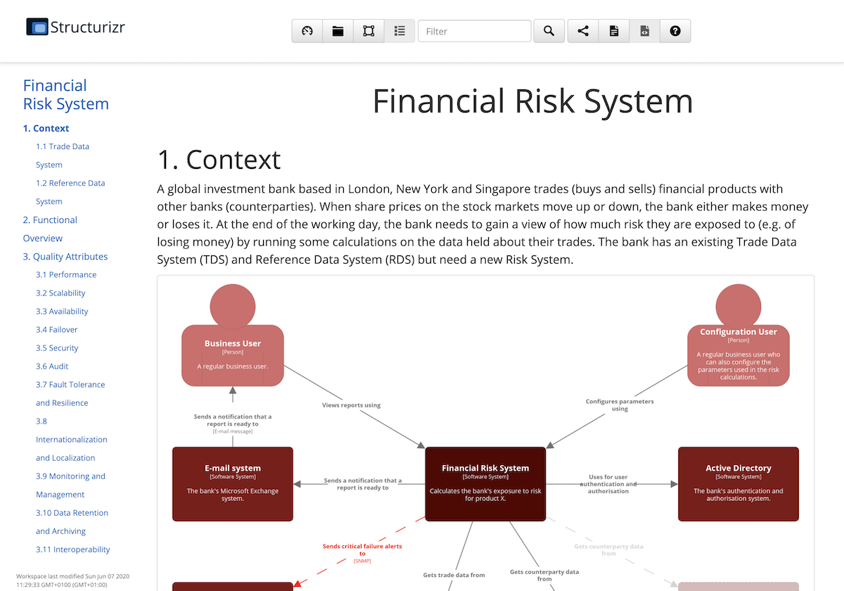

When discussion leads to changes in diagrams, Structurizr allows you to supplement your software architecture model with a decision log. This allows team members to quickly glance over what decisions lead to certain changes in the models. This will keep everyone from the team to the customer up to date on the latest versions.

Structurizr focusses on ease of use of the tool without over bloating it with extra features to get the most amount of clarity for developers and customers alike.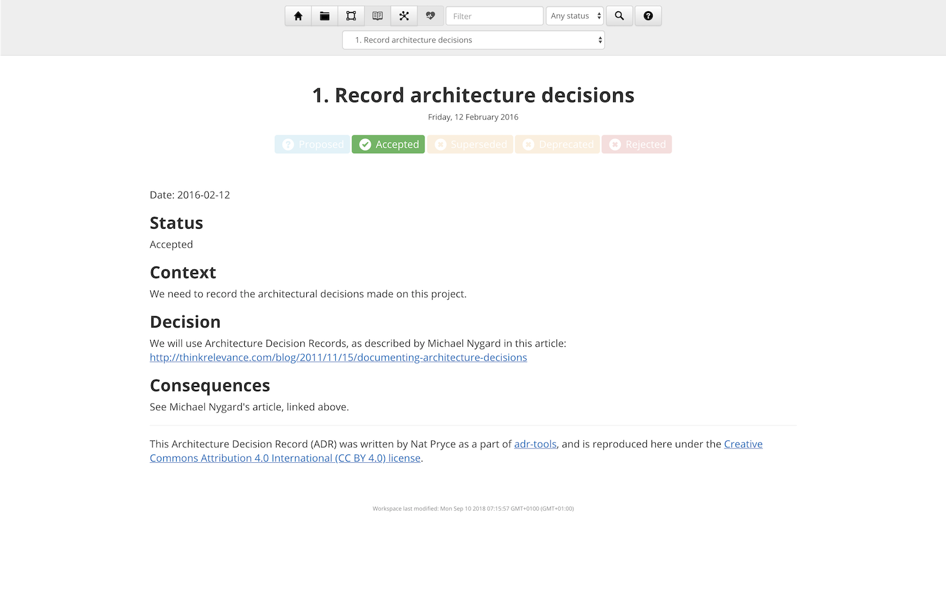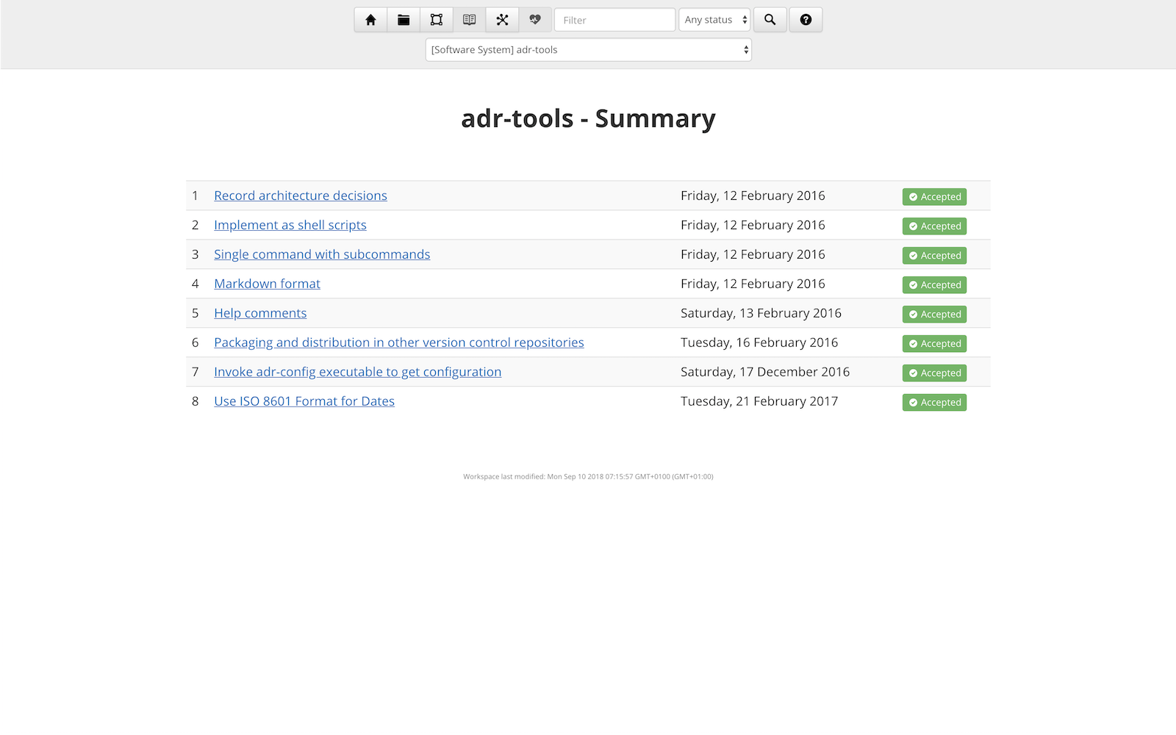

### 1.2 What are pros and cons to using this tool in creating a product backlog?

**Asana**

Pros:

* Asana provides automated routine tasks which removes excess time wasted.
* Rules allow for quick and guided building of issues
* Lots of pre-made templates to get set up quickly
* Visualize the work in multiple ways using Lists, Timelines, boards and calendar dates.
* Voting system
* Easy visibility of finished and unfinished workloads
* Integration with Github

Cons:

* Different pricing tiers for more features

### 1.3 Which industry standard diagrams is this tool able to create?

**Visual Paradigm**

Visual Paradigm supports almost any kind of industry standard diagram imaginable with most even being available in the community edition. The downside to this is that it might be more difficult to navigate through but at least you know that you have the supported functionality for it.  
To access the full feature list you can click on [this link](https://www.visual-paradigm.com/support/edition-comparison.jsp). For a glimpse of some of the diagrams layed out, you can see below:  
 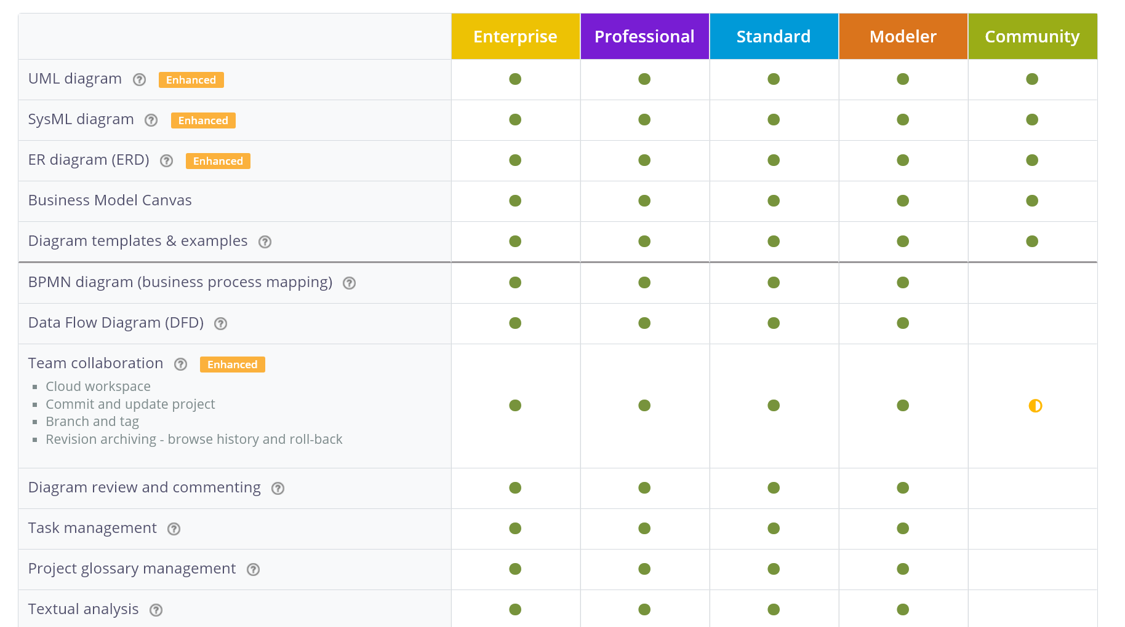

## Maarten

### 2.1 How does this tool aid in determining customer needs?

VersionOne - There’s multiple options to integrate applications such as Jira, CA Agile, ServiceNow, Microsoft TFS, HP, Saleforce.com, Perforce, and GIT into your VersionOne project. They promote their all in one options for an agile way of working for enterprises. Version one can scale to hundreds of teams and thousands of members, getting everybody involved in the process. The built in support for SAFe and DevOps can help with this.

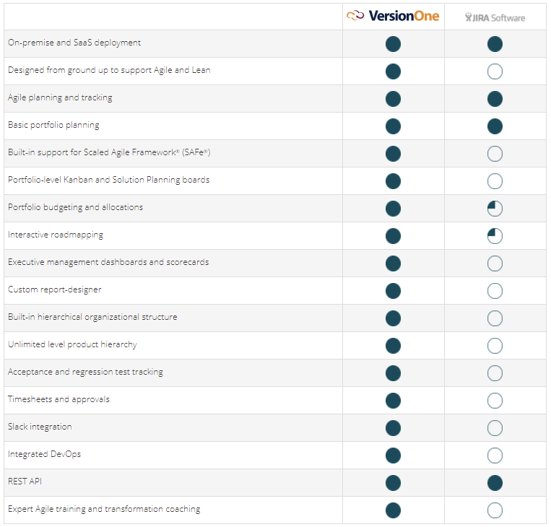

VersionOne also provides a service for internal and external stakeholders to stay apprised and up to date with roadmap status and strategic plans.

### 2.2 What are pros and cons to using this tool in creating a product backlog?

VersionOne- Something that can be considered to be a pro and a con is that they offer so much that it’s difficult to have an overview of what you actually want to use. Anything regarding an agile way of working can be done with this tool. For first time users this tool is very overwhelming with all the things it can do.  
All the sprint planning is done via tasks, these can be as detailed as you wish. Assign them to people within your team, assign a time limit within the sprint, and assign a score to how important the task is within the sprint. These tasks then get automatically placed within a backlogging system. These tasks are then also presented when you are making the new sprint planning.

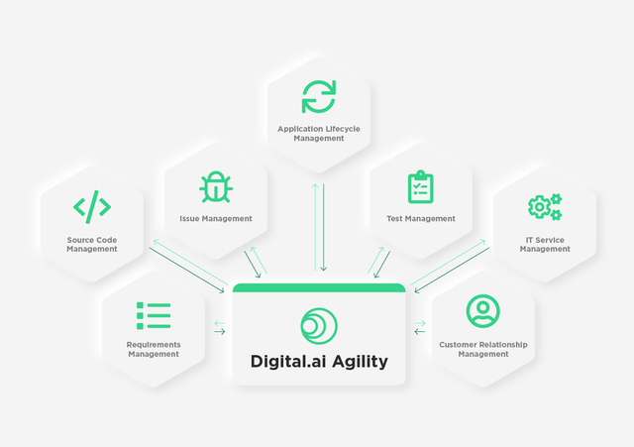

### 2.3 Which industry standard diagrams is this tool able to create?

Archi- <https://www.archimatetool.com/downloads/Archi%20User%20Guide.pdf>

Archi has the ability to draw any industry standard diagram that is required. However when you create a new project within the application it is automatically structured to follow the C4 model. It has different layers of models that you can easily switch between to create relationships/connections between all the different diagrams.

The pallet options have all the standard notations ready to use. The way the program is laid out is mainly focused on enterprise architecture.

-Side note: VersionOne changed their name to “Digital.ai Agility Enterprise Agile Planning”

## Faruk

### 3.1 How does this tool aid in determining customer needs?

C4-PlantUML combines the benefits of PlantUML and the C4 model for providing a simple way of describing and communicate software architectures – especially during up-front design sessions – with an intuitive language using open source and platform independent tools.

### 3.2 What are pros and cons to using this tool in creating a product backlog?

ClickUp

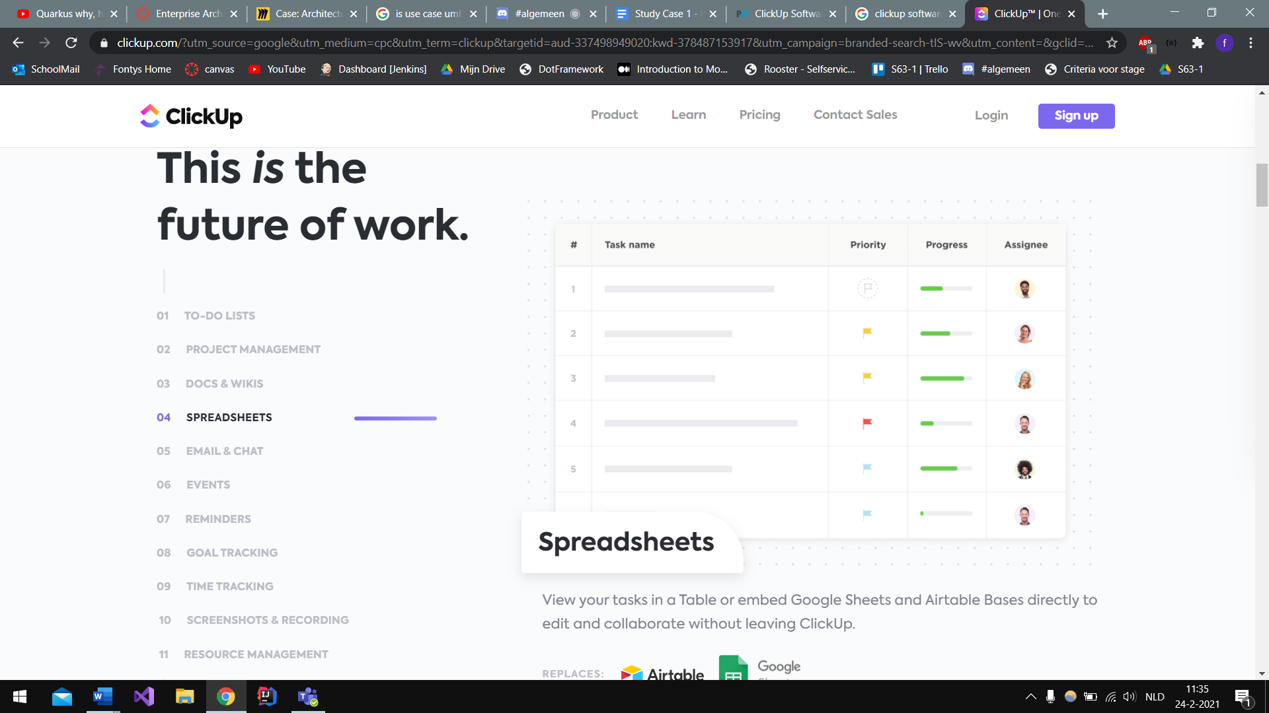

Pros:

* It can replace some other tools because it has the features of those tools.
* Suitable for teams and solo users. ClickUp provides teams powerful tools.
* Efficient dashboard view.
* Full-featured free version.
* Clickup continually provides new features, improvements, and enhancements based on what their customers need.
* Friendly layout.

Cons:

* Too many features.
* Too many options for customization.

### 

### 3.3 Which industry standard diagrams is this tool able to create?

C4:

* System Context & System Landscape diagrams
* Container diagram
* Component diagram
* Dynamic diagram
* Deployment diagram

UML:

* Sequence diagram
* Usecase diagram
* Class diagram
* Object diagram
* Activity diagram
* Component diagram
* Deployment diagram
* State diagram
* Timing diagram

The following non-UML diagrams are also supported:

* JSON data
* YAML data
* Network diagram (nwdiag)
* Wireframe graphical interface (salt)
* Archimate diagram
* Specification and Description Language (SDL)
* Ditaa diagram
* Gantt diagram
* MindMap diagram
* Work Breakdown Structure diagram (WBS)
* Mathematic with AsciiMath or JLaTeXMath notation
* Entity Relationship diagram (IE/ER)

Text editors and IDE that support PlantUML

* Integrate it with TinyMCE Editor
* Integrate it with CKeditor
* Use the Eclipse Plugin
* Use a NetBeans Plugin
* Use it with NetBeans
* Use it with Intellij idea
* Run it directly from Word
* Use Gizmo to render PlantUML diagrams within Word
* Run it directly from Open Office
* Run it from Emacs
* Run it from Sublime Text Editor
* Run it from VIM (And use F5 key to update, Vim PlantUML Syntax, or PaperColor Theme)
* Use it with LaTeX
* Use it with mbeddr
* Use it with GEdit
* Use it with Brackets
* Use it with Atom
* PlantUML language package for Atom
* UDL for Notepad++ to support the PlantUML language syntax
* Visual Studio Code plugin
* Another Visual Studio Code plugin
* PlantUML syntax highlighter
* Generates UML class diagrams from MATLAB m-code

## 

## Nick (LucidChart, Monday.com, StarUML)

### 4.1 How does this tool aid in determining customer needs?

**Lucidchart**

Lucidchart is a tool to create diagrams. It is very well integrated with other business apps, e.g. Github, Jira and Salesforce. This makes it possible to use already existing data and in most cases it has two-way syncing. Which means your diagrams will always be up to date with your data. Lucidchart also offers a wide variety of models you can use to fit your needs.

In addition to the large amounts of models provided by Lucidchart, it has some great collaboration features. The diagrams update real time. Options to add remarks or questions to certain parts of the diagram.

### 4.2 What are pros and cons to using this tool in creating a product backlog?

**Monday.com**

Monday.com is a tool that helps a team keep track of progress. It looks like it is based on the agile method Kanban. Each row in the Ui can be seen as a task and can be assigned to someone and you can add a deadline and some other features.

Monday.com supports over 50 services. This includes services like Slack, Outlook, Microsoft Teams, Dropbox and Jira. These services allow your board to move information automatically. For example, you can sync all the dates from a particular board to your Google Calendar.

### 4.3 Which industry standard diagrams is this tool able to create?

**Lucidchart**

With Lucidchart you are able to create basically every model you can imagine. With over 100 different templates and plenty of object libraries, this tool will have a diagram that suits your or your company’s needs.

**StarUML**

StarUML supports the following diagrams:

* Use Case Diagram
* Class Diagram
* Sequence Diagram
* Collaboration Diagram
* Statechart Diagram
* Activity Diagram
* Component Diagram
* Deployment Diagram
* Composite Structure Diagram

## Jursley

### 5.1 How does this tool aid in determining customer needs?

**MooD software by CACI**

MooD Software allows stakeholders around the business to gain insight from architecture and design content. It creates accessible visualisations and process maps that relate complex technology systems to the business outcomes they support.

A wide range of stakeholders can view and interact with content via a web browser using the Active Enterprise technology to tailor views for particular users or persona groups. This can be used with customer needs techniques that visualize the mapping of the customer process and journey to achieve the desired business outcomes within an application.

### 5.2 What are pros and cons to using this tool in creating a product backlog?

**Microsoft Project**

**Cons**

Requires training to be used because of the vast amount of functionalities, this can be overwhelming for new users.

Cost constraints. Organisations need to purchase licenses for every user to be used on-premise.

File compatibility issues. Files saved with Microsoft Project can’t be opened with other types of file software. Making it impossible to send files to stakeholders or clients that don’t make use of Microsoft Project.

Operating software. The platform is limited to only run on Microsoft.

**Pros**

Integration. Microsoft Project is excellent for organisations that make use of the Microsoft 365 office suite and other Microsoft platforms (Teams, Skype, Sharepoint, Azure and etc.). This makes communication through Microsoft platforms like Outlook, Yammer and Skype a breeze. The ribbon interface is similar to that of Excel, making users with prior experience pick it up faster.

Dependability. Microsoft Project has been around commercially since 1984 making it a mature platform that runs stable and continually receives updates.

Customer support. As a Microsoft platform organisations have access to Microsoft support which is known to be reliable.

Flexibility. Flexible enough to be used as a roadmapping tool and financial management, which gives overhead to the stakeholders and clients on where the project is going with connected costs.

Agile. Microsoft Project offers different types of task boards to support an agile methodology way of working.

### 

### 5.3 Which industry standard diagrams is this tool able to create?

**Microsoft Visio**

Microsoft Visio has templates that ranges from enterprise software, costumer processes, service processes, different types of UML used in documentation of software architectures and more. If the template you are looking for is not there it is possible to create your own with import of shapes. This makes the platform powerful and versatile.

On the down side it comes with a price tag and it’s not possible to use the files in other platforms since it is part of the Microsoft 365 suite.

# Advice

The suitable solution for the process of coming to a shared understanding of the system between development and customers we have come up with is LucidChart**.**  
This tool is great at determining customer needs because it supports many different diagrams, is backed and used by big companies so should be supported for the foreseeable future and real time collaboration which allows customers to be more involved in a clear and concise manner.

Creating a product backlog should be quick and intuïtive, VersionOneis great for creating new issues for the backlog. By using the built-in sprint planning tool new issues can easily be added to the backlog while maintaining clarity for the whole development team.

In order to ensure consistency between projects, an architecture outline that describes the architecture from multiple viewpoints should contain the following diagrams and use the following tooling:

|  |  |  |  |  |  |  |
| --- | --- | --- | --- | --- | --- | --- |
|  | **System Context Diagram** | **Container Diagram** | **Component Diagram** | **Class Diagram** | **Use Case Diagram** | **Sequence Diagram** |
| **LucidChart** | **X** | **X** | **X** | **X** | **X** | **X** |